# SunFounder 10.1'' Touch Screen

# Introduction

* **Plug & Play**
* **Capacitive Touch**
* **10-point Touch Screen**
* **Resolution:** 1280x800
* **Power:** DC 12V/5A
* **Aspect Ratio：**16:10
* **Consumption:** 4W
* **LCD Type:** IPS

SunFounder 10.1'' IPS monitor is a 10-point capacitive touch screen with a resolution of 1280x800, bringing you perfect visual experience. It works with various operating systems including Raspberry Pi OS, Ubuntu, Ubuntu Mate, Windows, Android, and Chrome OS (you may need an USB extension cable).

For more information, please refer to the online tutorials: <https://ts-10.rtfd.io>

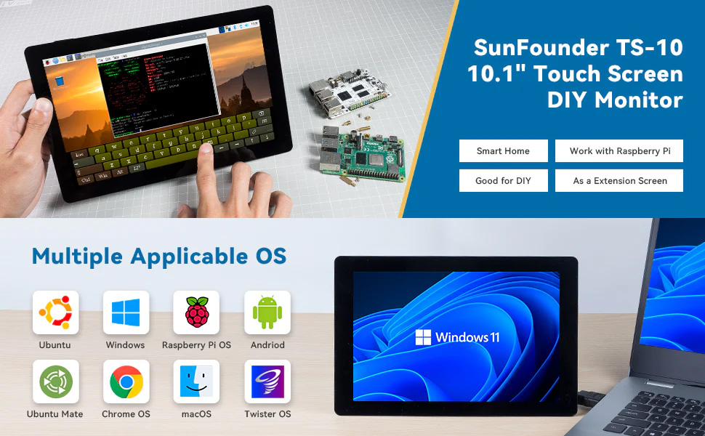

# Package List

* 10.1'' IPS Touch Screen x 1
* M2.5 x 18 Copper Standoff x 5
* M2.5 x 30 Copper Standoff x 4
* M2.5 x 6 Screw x 5
* Speaker x 1
* Acrylic x 1
* Screwdriver x 1
* Wrenches x 2
* HDMI Cable x 1
* Type-C USB Cable x 1
* USB Touch Screen Cable x 1
* 12V Power Adapter x 1
* Tape x 4

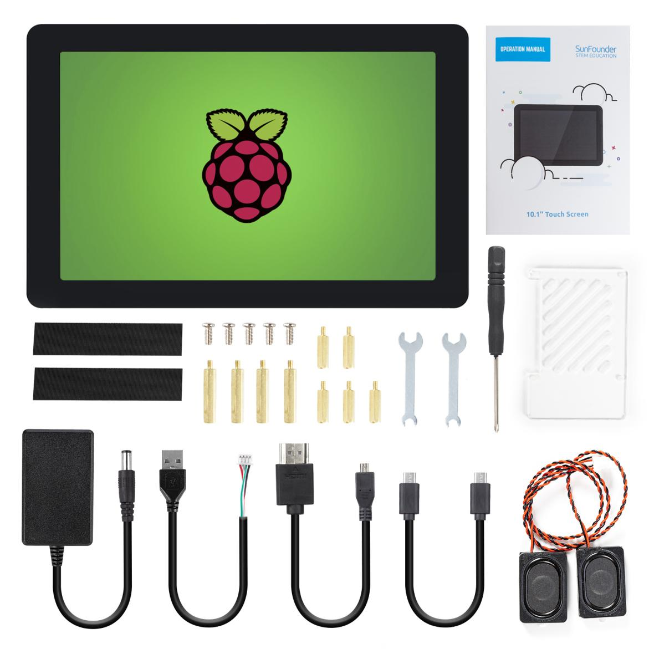

# Hardware Description

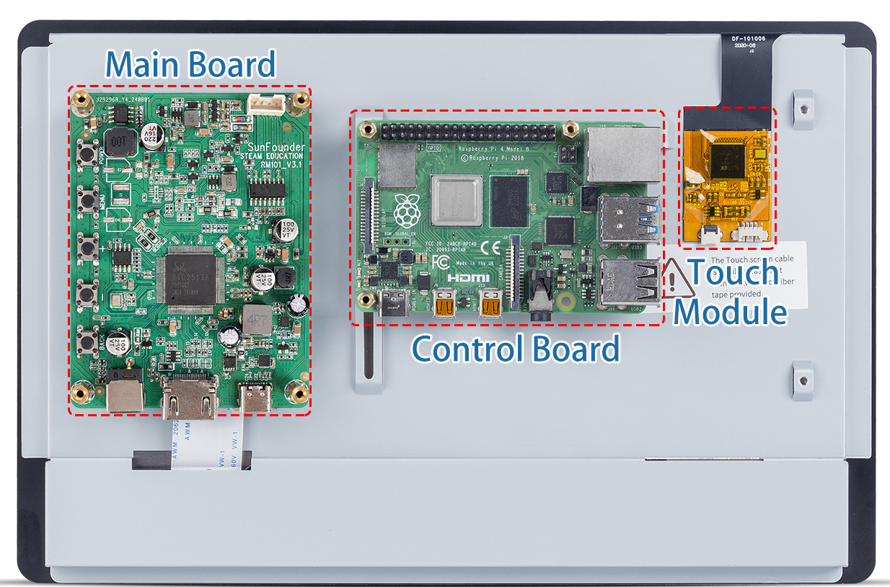

* **Main Board**: It is mounted on top to control the display.
* **Control Board**: It is a cross slot structure with one side movable, so you can mount different size of control board.
* **Touch Module**: This is the module used to let the display get the touch function, you need to connect it to the USB port of the control board through the USB cable provided by us.

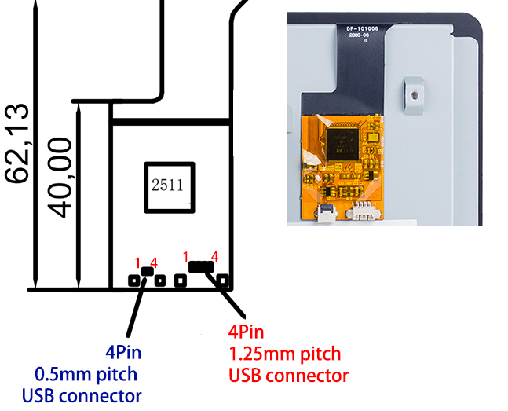**Touch Module**

There are two types of 4pin connector on the touch module, with the pin serial number shown on the figure.

Here are the definitions of the pins:

* Pin 1: VDD(5V)
* Pin 2: D-
* Pin 3: D+
* Pin 4：GND

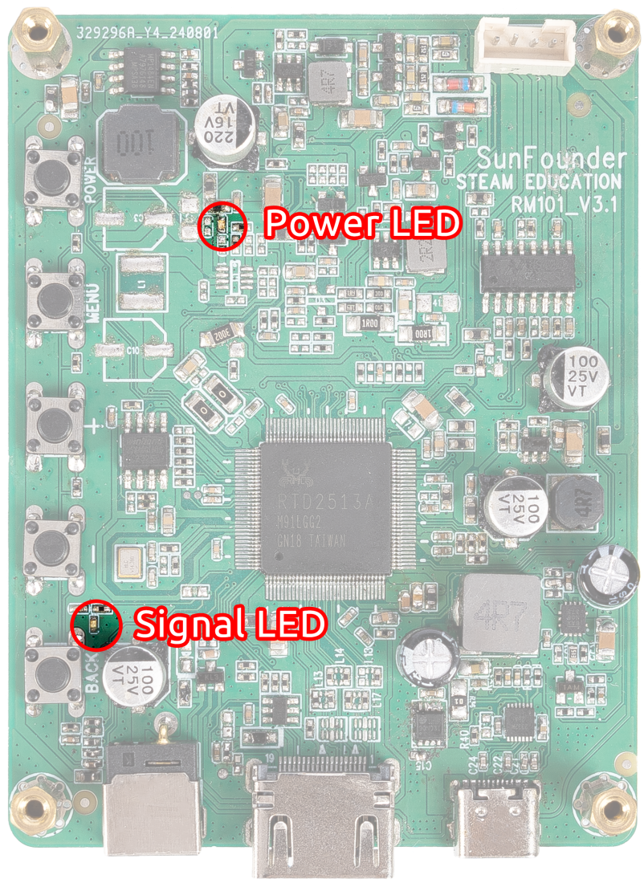**LED Indicators**

* Power on the screen, after the Signal LED flashes one time, it lights on continuously; and the Power LED lights on immediately.
* If there's no HDMI signal, only the Power LED will turn on.
* If there's an HDMI signal, these two LEDs will turn on.
* If you press the power button, the Signal LED will turn off and the Power LED will keep turning on.
* If you remove the power adapter, both of the two LEDs will turn off.

**Buttons**

Buttons on the Driver Board and their functions:

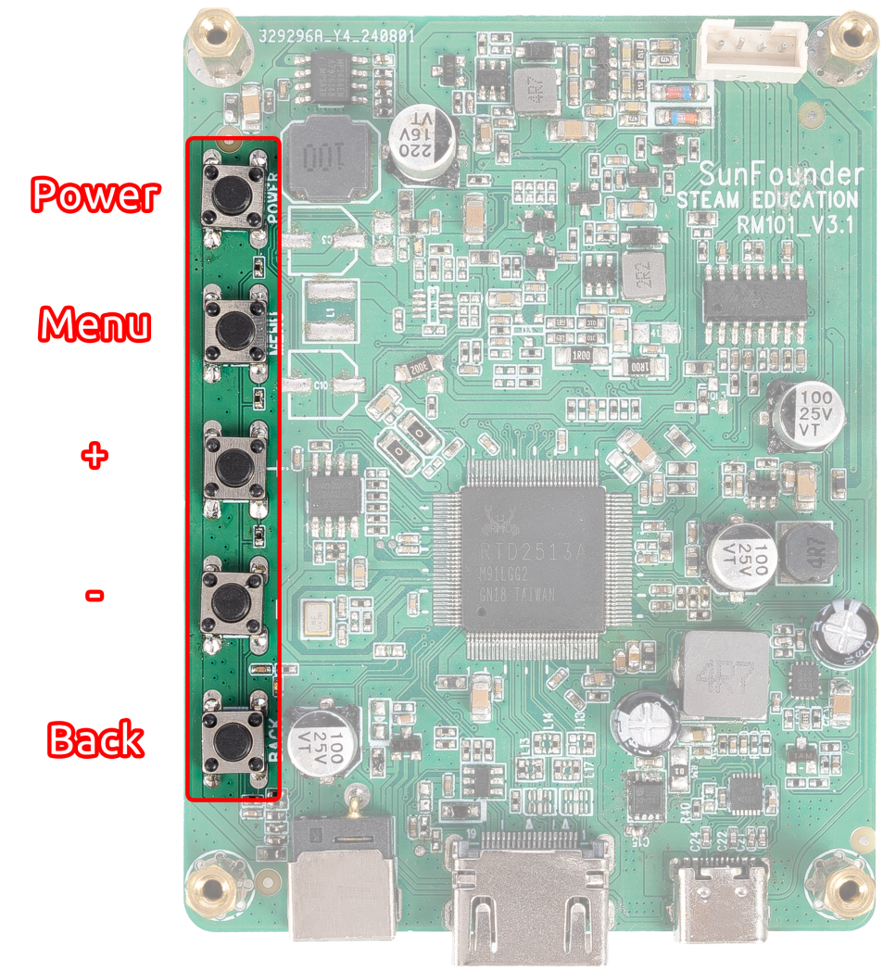

|  |  |  |  |  |  |
| --- | --- | --- | --- | --- | --- |
|  | **Working** | **Sleep** | **Menu** | **Volume Adjust** | **Brightness Adjust** |
| Power | Enter Sleep state | Enter Working state | Enter Sleep state | Enter Sleep state | Enter Sleep state |
| Menu | Open the Menu |  | Confirm |  |  |
| “+” | Increase Volume |  | “+” | Increase Volume | Increase Brightness |
| “-“ | Decrease Volume |  | “-“ | Decrease Volume | Decrease Brightness |
| Back | Open the Brightness adjust |  | back | back | back |

**Ports**

On one side of the Driver Board there are ports of HDMI input, 12V power input, and 5V/3A USB power output and Speaker Port.

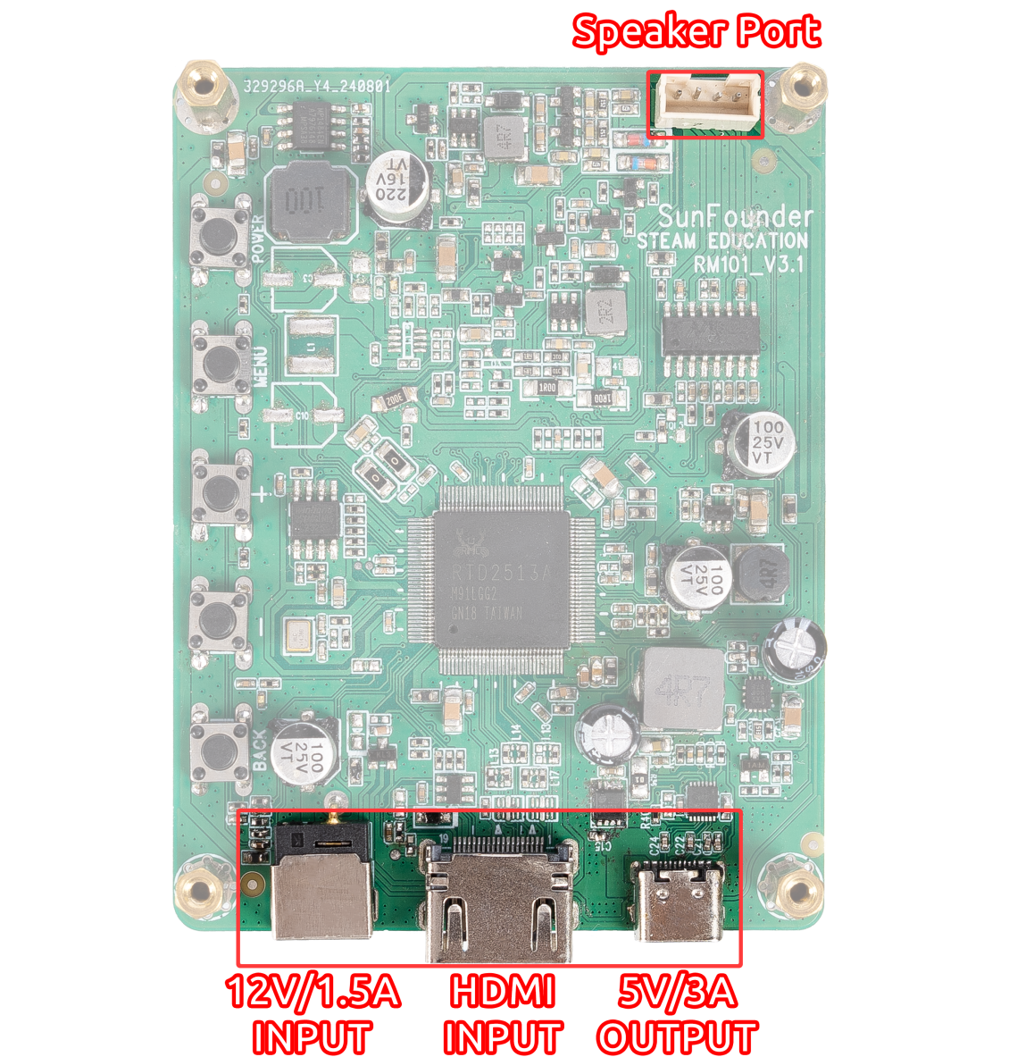

# Connect the Raspberry Pi and Screen

**Step 1**

Fix the Raspberry Pi (or other boards) on the screen back case. There are a vertical slot and a horizontal one on the back of the screen, so you can fix boards with different sizes by moving the nuts and standoffs with the small wrench.

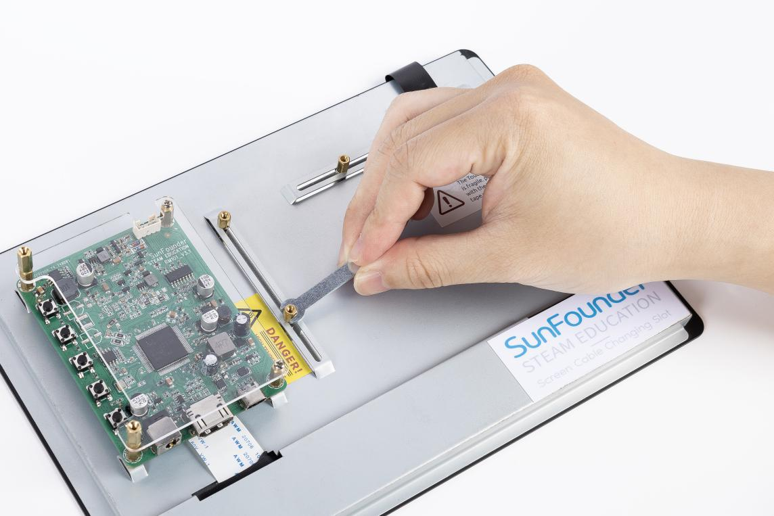

**Step 2**

If you want to use a Raspberry Pi with the screen, then you don't need to adjust the standoffs since they are preset for it. Just place the Raspberry Pi on the plate and fasten them with 2.5*18 standoffs.

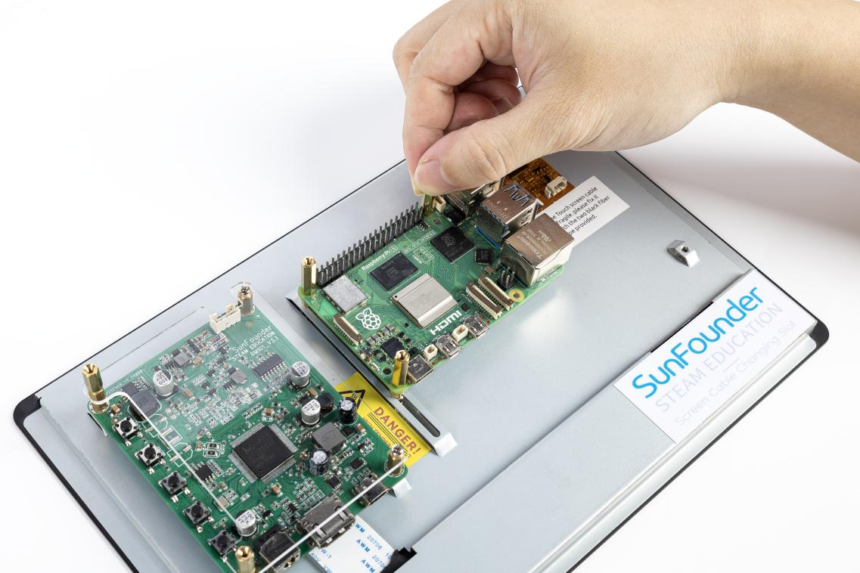

**Step 3**

Secure the acrylic protect plate with 2.5*6 screws.

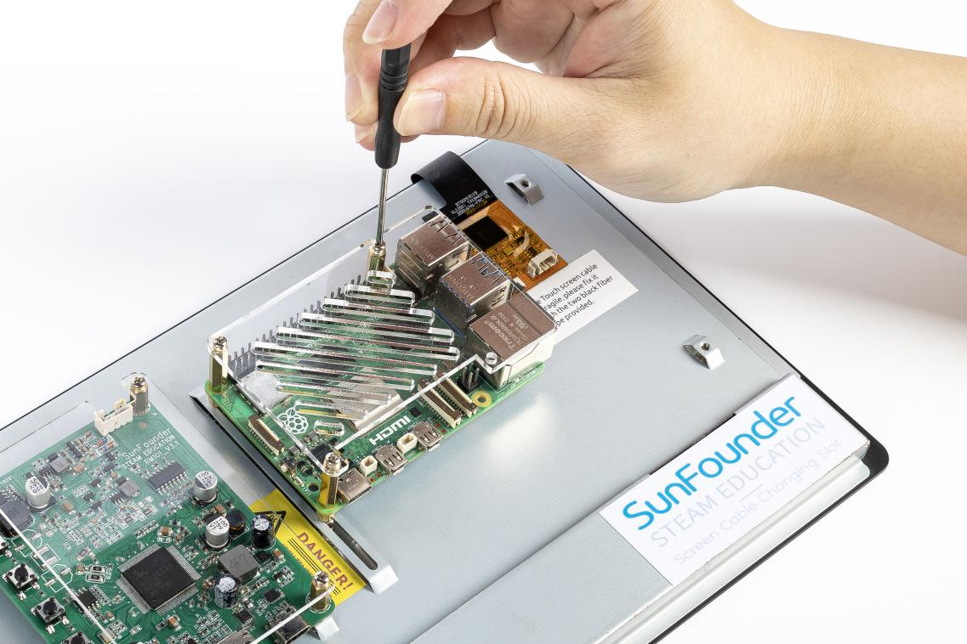

**Step 4**

Insert the two 2.5*30 standoffs into the holes on the back to keep the screen balanced.

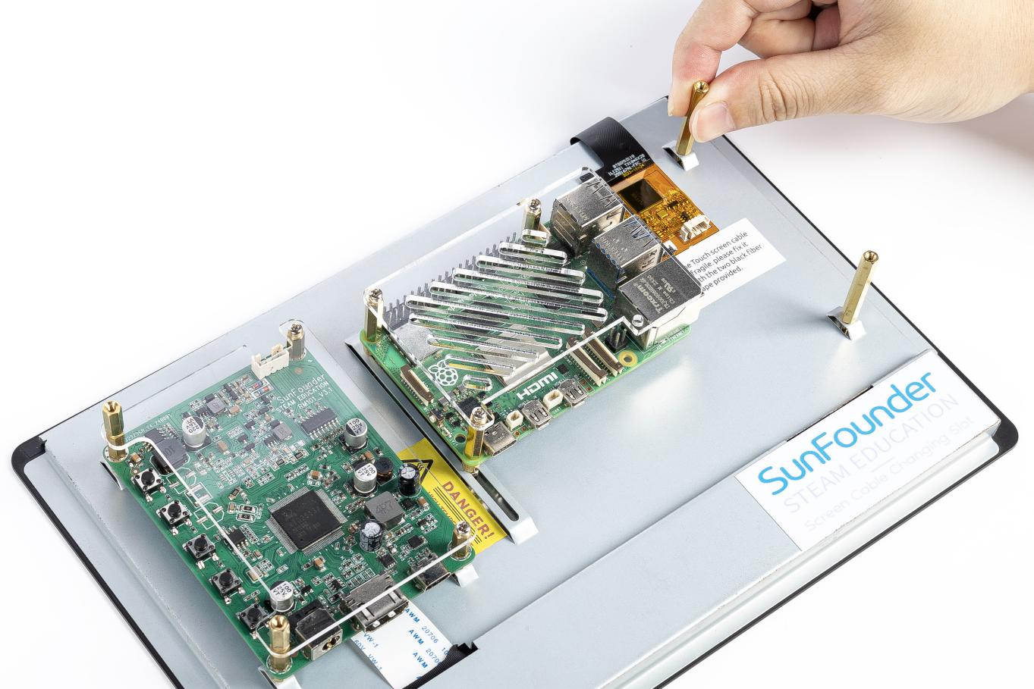

**Step 5**

Insert the speaker wires as shown in the picture.

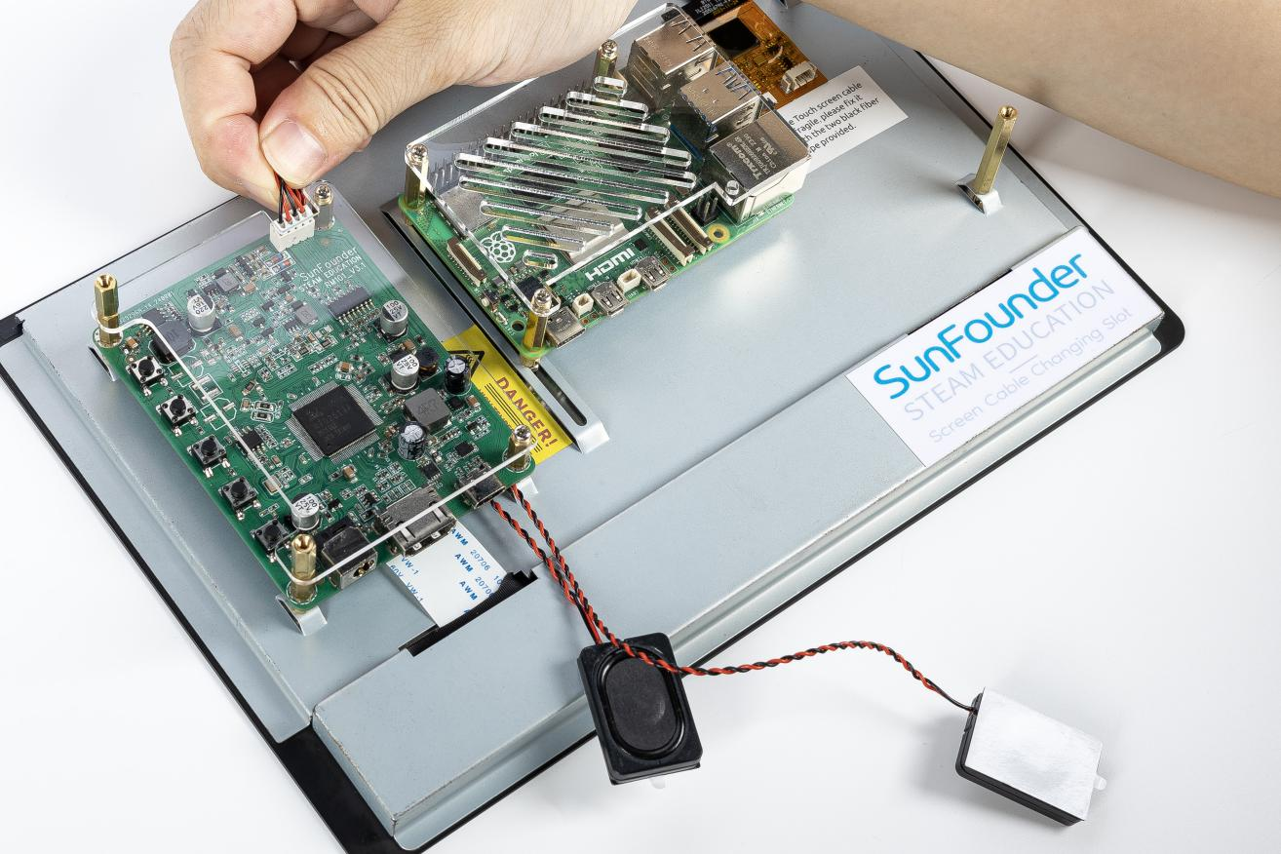

**Step 6**

Attach the speaker.

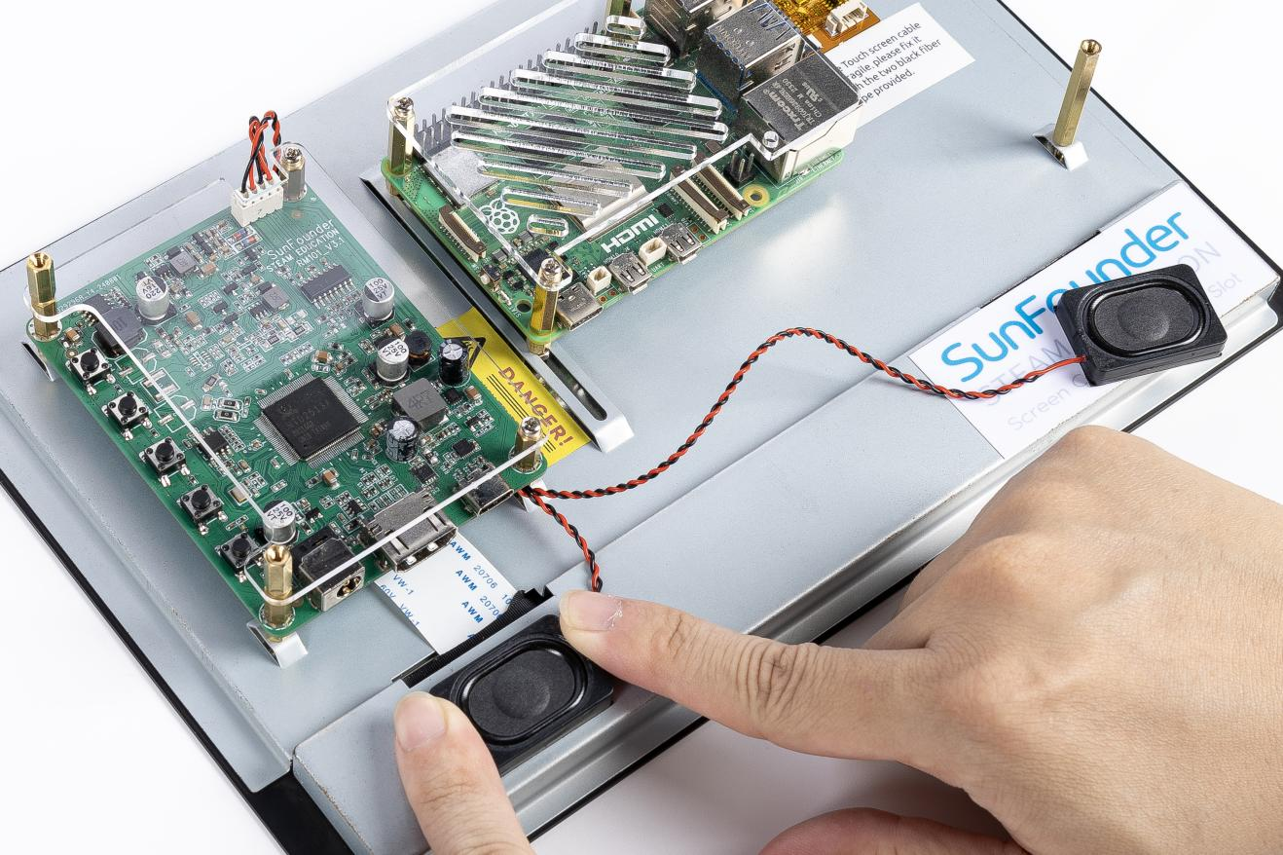

**Step 7**

Secure its wires with tape.

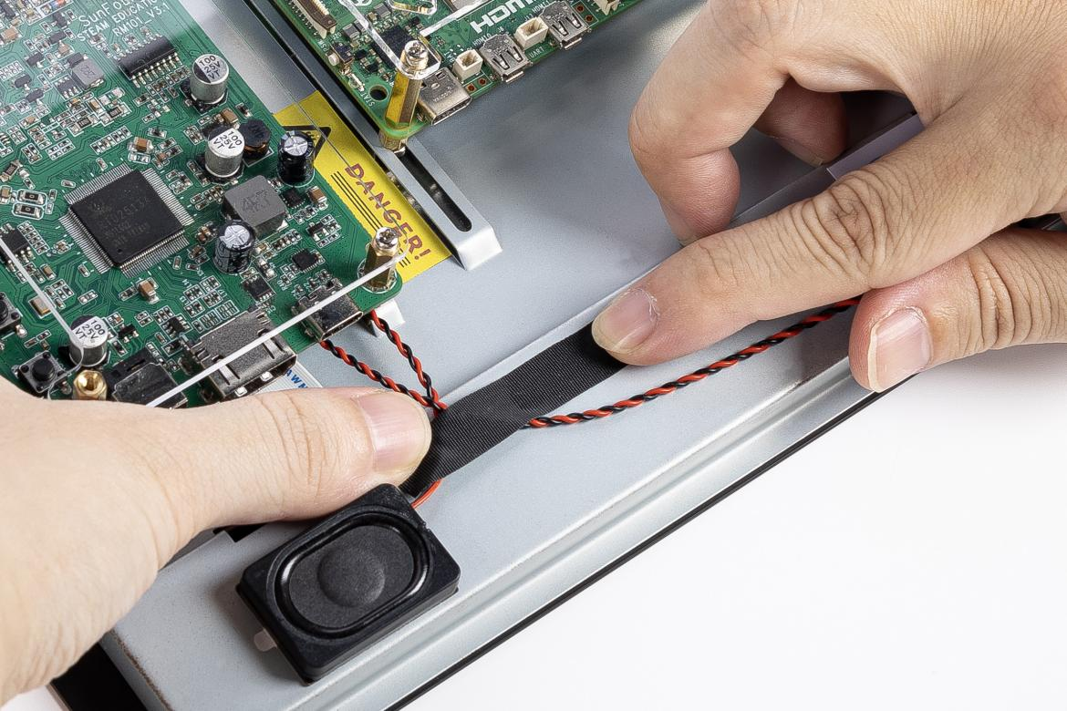

**Step 8**

Connect the HDMI port of the Raspberry Pi (4 or 5) and the screen via an HDMI cable.

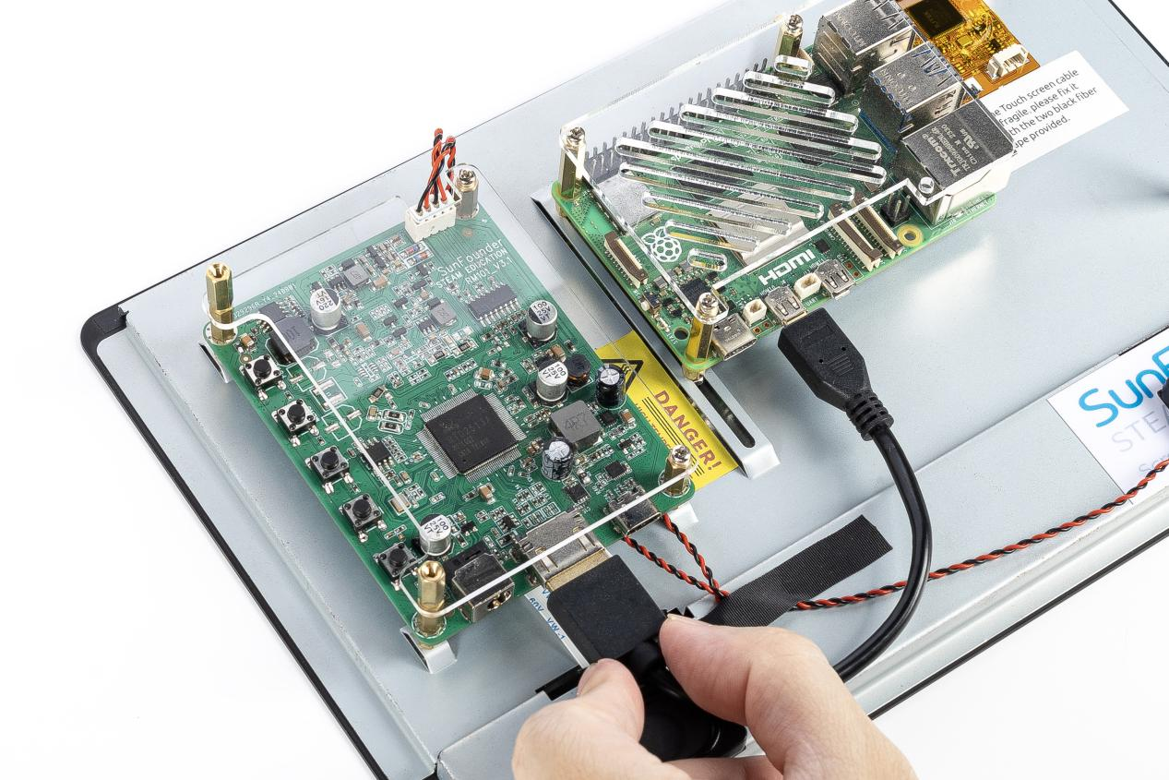

**Step 9**

Connect the power port of the Raspberry Pi to the USB port of the main board via a USB cable.

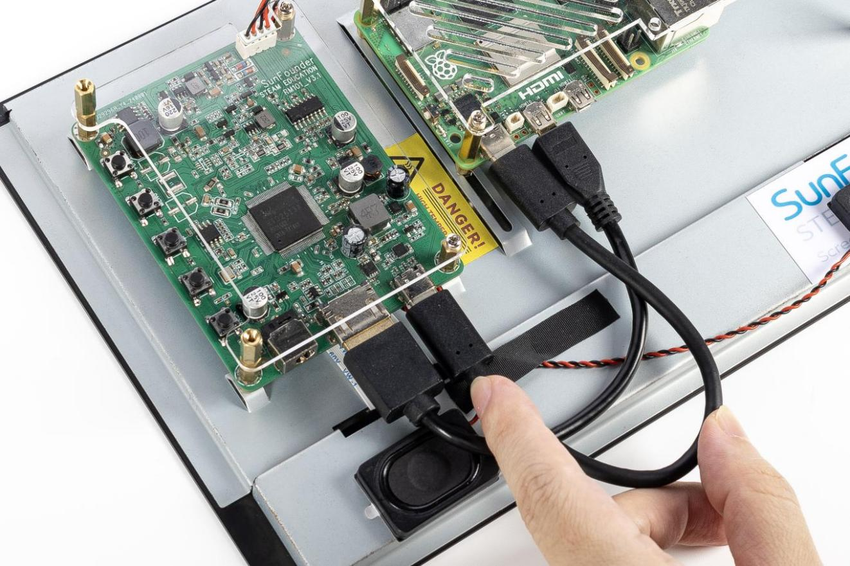

**Step 10**

Connect the USB port of the Raspberry Pi and the screen with a 4-pin USB cable. To prevent the cable from falling off, use tape to fix it.

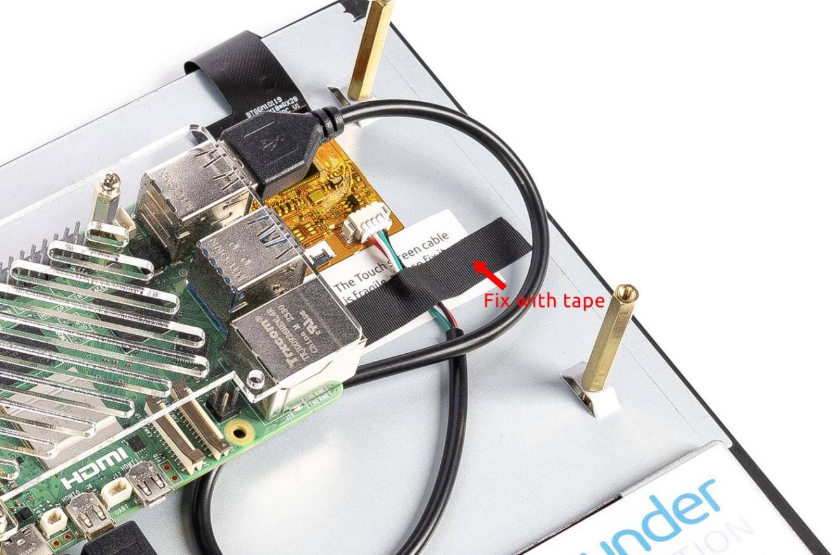

**Step 11**

Connect the power cable of the supply to power the main board of the screen.

Note: Before plugging in the power cable, you need to refer to the online tutorials: **https://ts-10.rtfd.io** to install the Raspberry Pi OS to the Micro SD card, then insert the Micro SD card into the Raspberry Pi and finally plug in the power cable.

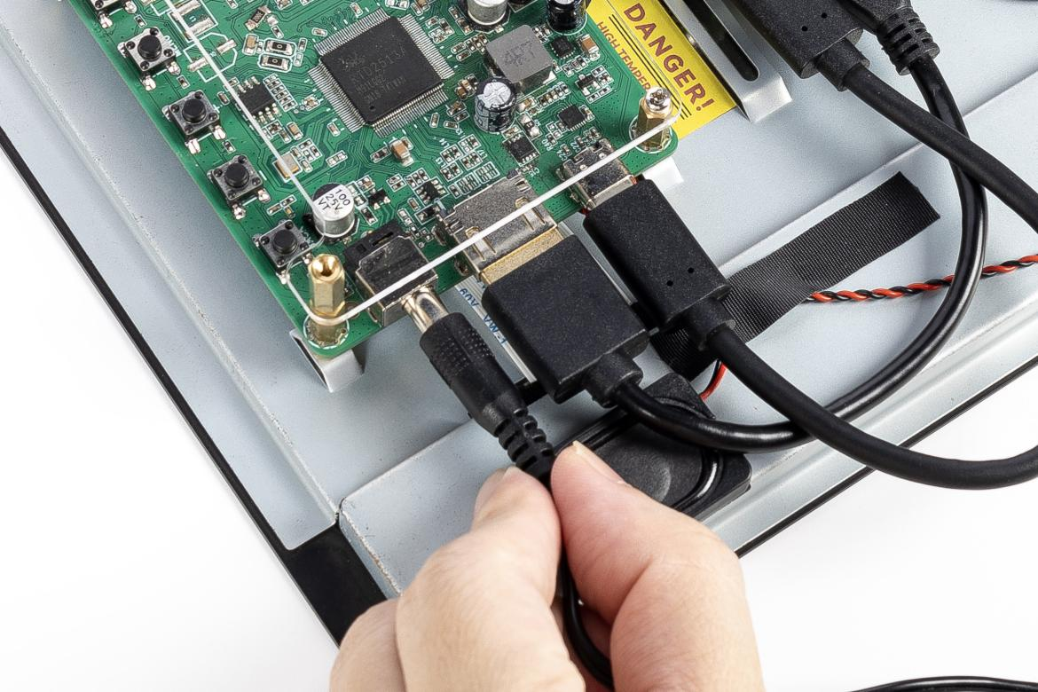

**Step 12**

Then power it on and the **boot screen** will appear.

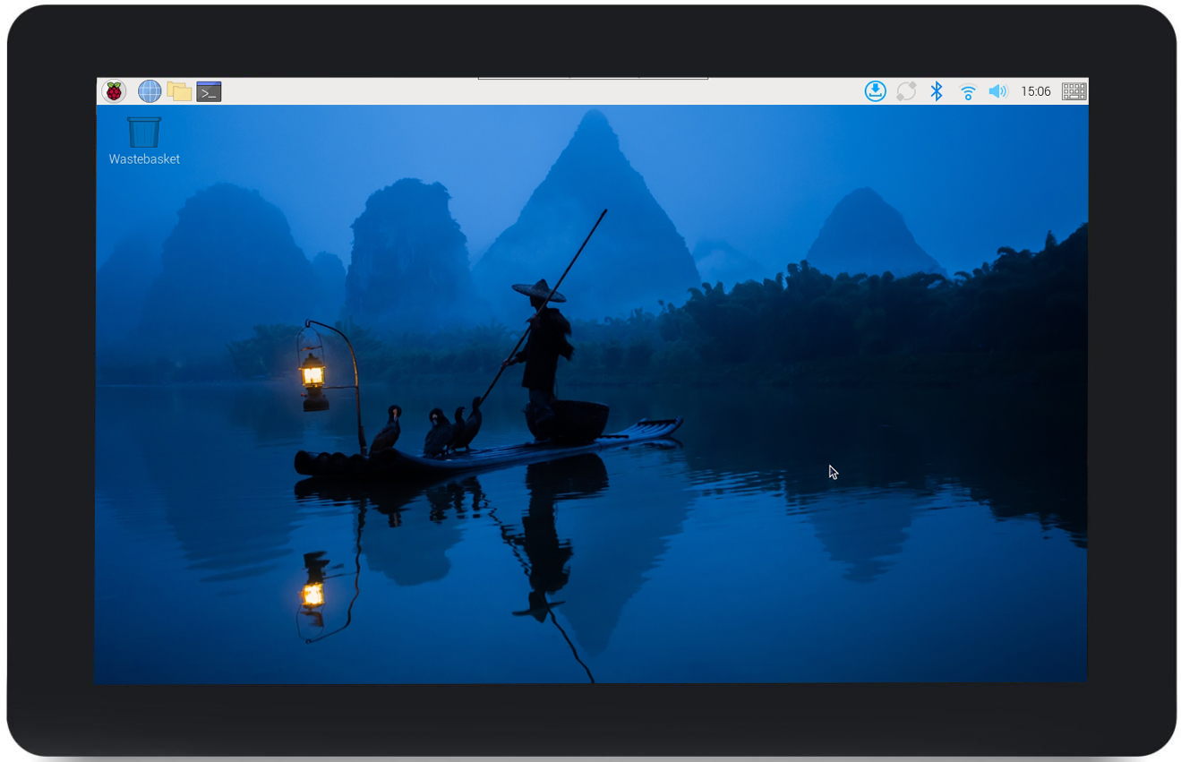

# Using as Extension Screen for PC

Connect the computer with the main board via an HDMI cable, and connect the USB port of the PC and the screen with a 4-pin USB cable. Now you can use the screen as an extension one of your computer.

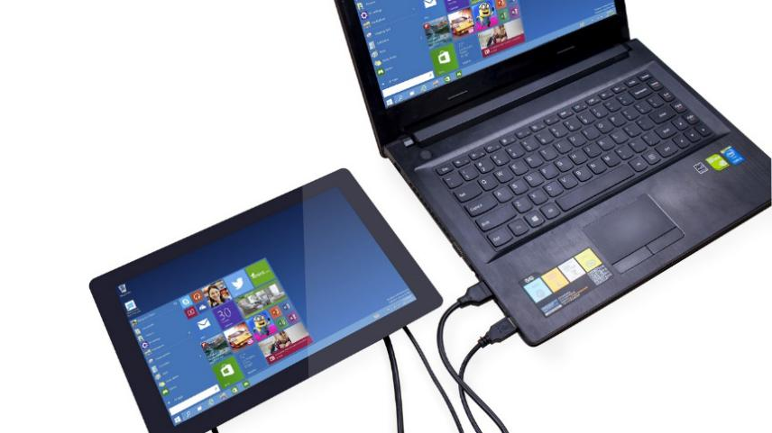

# FAQ

## **The screen shows No Signal after the device is turned on?**

* Please check if all the cables are plugged in properly.
* Check if the control board (Raspberry Pi) is on.
* Check if the SD card has the correct system installed.

## **Can’t touch?**

* Make sure the touch module is connected to the control board (or device) via the USB touch cable.
* Check if the touch module is damaged, if so please contact us.

## **Use of the touch pen**

* This display works with passive capacitive stylus, while active capacitive does not.

## **The LCD display cannot be turned on without connecting other devices.**

* This is a normal phenomenon, please use it after connecting Raspberry Pi or other devices.



Would you like to know what interesting projects you can do with this screen?

Please refer to "**PROJECTS AND ACTIVITIES**" at: <https://ts-10.rtfd.io>